**Walk 5 Brampton Abbotts and Hole-in-the-Wall**

Last walked in March 2017

**Description.** An 8 km (5 mile) Moderate walk along fields, roads, river and railway. This walk has 12 stiles. This is an edited version of the Hereford Times January 2012 walk.

**Start.** Brampton Abbotts. Explorer Map 189 Grid 601265.

**Direction from Belmont roundabout** (Turn milometer to zero). Follow the A49 to Ross-on-Wye and at 12.9 miles, at the roundabout you TL towards the M50. At the next roundabout, 14.3 miles, you go straight across towards the M50. At the next roundabout, 14.8 miles you TL towards Ledbury on the A449. At 15.2 miles you TL towards Brampton Abbotts. At a T-junction, after 16 miles, you TL towards Ross-on-Wye. A little further on you TR towards Brampton Church and at 16.2 miles you arrive at the church. Park beside the churchyard stone wall.

**1.** **Brampton Abbotts Church.** ***The church closed in 2008, it says it is waiting for a health and safety check.*** With the wall and lynch gate on your R, walk down the road, passing a sign ‘Wellmead’ on the house wall on your L. At the next road on your L, just before the village Hall, TL and walk along to the end of this tarmac road, then continue on for a few more paces to reach the dirt track and the last cottage on the R called ‘Townsend’. Just passed the last cottage you TR across a stile and into **F1**. Bear L and cross the field to cross another stile into **F2**. Go across a large cropped field towards a hedge elbow, (a lone tree is on the L). Continue in the same direction with the hedge on your R, into **F3**. Carry on up passed trees on your R. From the tree corner you continue in the same direction across a cropped field towards a large corrugated farm building, to go thru a metal gate onto a road. TR, continue along the road, passing the Hill of Eaton Courtyard on your L, and then an old farmhouse on your R, which is just before the road bends to the R, and when it does you TL over a stile into **F4**.

**2. Hill of Eaton.** Go quite steeply down the pasture to cross a stile and go up a fenced path immediately L of trees of Vicarage Wood. Cross a stile into **F5**. Keep on upwards, along the R edge ***(with great views opening out west and north)*** and over the crest. Go thru wooden gate into **F6**. Start to descend, bearing very slightly R thru a wooden gate and down a wide tree-lined track. In front of next gate, TR and go upward for about 50 paces, and then bear L to cross over a stile/metal gate into **F7**. Follow the L edge to the L corner and TL to go thru a small metal gate and go along a narrow enclosed path to reach the road at the Hole-in-the-Wall, (a red post box is on your R).

**3. Hole-in-the-Wall.** TL and go along the quite road, passing the Foy Bridge on your R that goes over the river Wye. 275m beyond the bridge, and opposite Orchard Cottage, you TR and go thru trees along the Wye Valley path. Go thru a gate into **F8**, (Foy Church is on the opposite bank to the R). Go straight ahead near bottom R edge of the long pasture to cross a stile into **F9**. Keep ahead near to the R edge, (ignore a metal gates on your R hand side) to reach the far end. Go thru a metal kissing gate, then in and out of the bottom edge of trees and into **F10** where you TL. Continue on to the end of the trees on your L, (Monks Grove). Then continue in the same direction across a clear patch of land, to continue along the field edge, with a line of trees on your R. Go ahead to marker post at path junction. TR and 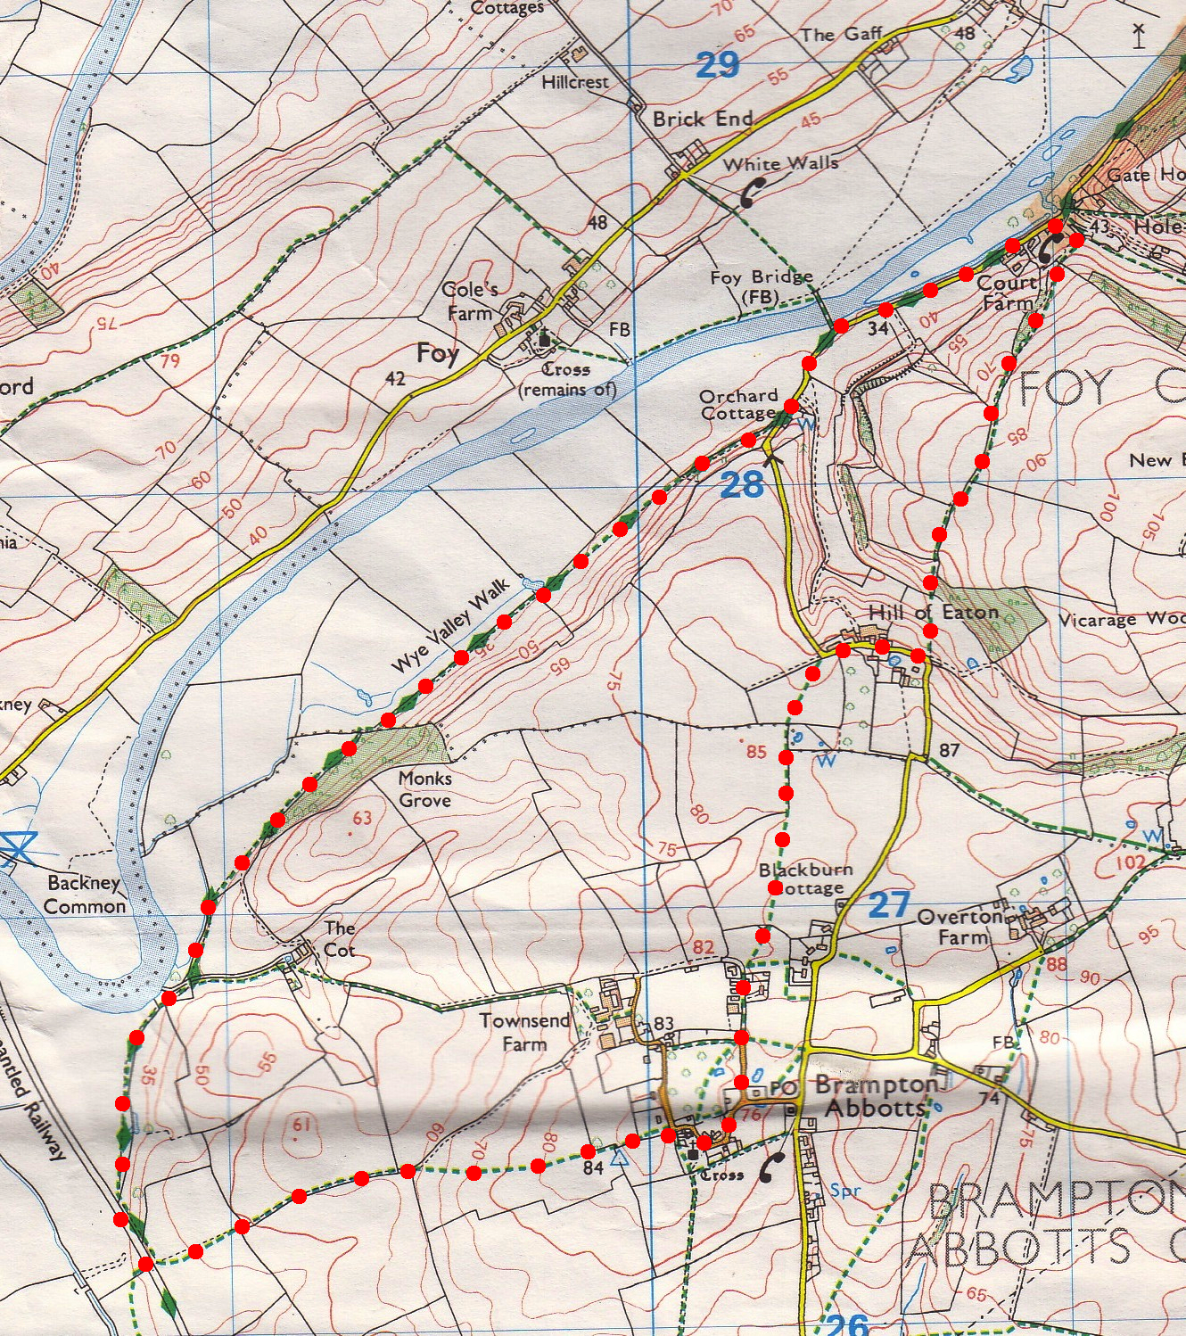continue along the track.

**4. Marker Post. *If you want to you can continue along the riverbank for 150m to see the memorial to H E. Who ever he was?*** Go on past another marker post (if its still there) and a little further on, (opposite a wooden bench that’s on the river bank) you TL and go along the L edge of a flat field **F11**. In the L corner of the field you go thru a small metal gate and up nine steps to an old railway line where you TL. Go along to a marker post at cross tracks and TL. Go up wide gravel track, passing a green gas hut on your R. ***Views R to Ross, Chase Wood and Penyard Park.*** After about a further half a kilometre the track bends slightly L, slightly to the R is a gap in the hedge, which you go thru into **F12**. Continue in roughly the same direction, heading diagonally up to the top R corner of the huge field. Head towards a sandy coloured house, when seen. Skirt R of a hedge elbow and over 2 stiles ahead. Emerge at drive of Clouds Harrow and follow road R around old school House to lych-gate.

**3**

**2**

**4**

**1**